**ASSESSMENT 2**

Python and MySQL

assessment test 2 hours

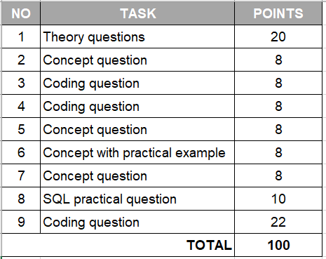

| 1. **Python / SQL theory questions**  * questions 1 to 5 ⇒ 2 points * question 6 ⇒ 10 points | **20 points** |
| --- | --- |

1. What is Thread and Multithreading?
2. What is Concurrency and Parallelism and what are the differences?
3. What is Garbage collector? How does it work?
4. What is Transaction Management in a relational database (give an example)?
5. What is an endpoint and what are the most common methods to interact with the API data source?
6. What is data normalisation in SQL? Please provide an example (any) of a database restructuring using primary/foreign keys to maintain data integrity.

| **Discuss Exception handling (4 pts) and debugging in Python (4 pts)** | **8 points** |
| --- | --- |

| 1. **Write a function that takes in a non-empty array of integers that are sorted in ascending order and returns a new array of the same length with the squares of the original integers also sorted in ascending order.**   **Example Input:**  numbers = [1,2,3,5,6,8,9]  **Example Output:**  [1,4,9,25,36,65,81] | **8 points** |
| --- | --- |

| 1. **Write tests for the newly created Sorted Squared Numbers function (in Q3). Provide a brief explanation for your test case options.** | **8 points** |
| --- | --- |

| 1. **Agile methodology: name and describe any 2 of the main roles in a Scrum Agile team.** | **8 points** |
| --- | --- |

| 1. **Discuss advantages and disadvantages of TDD (Test Driven Development):** | **8 points** |
| --- | --- |

| 1. **What is a Python DB cursor? Provide an example** | **8 points** |
| --- | --- |

| 1. **Given an example table below**  * Write a SQL query to find the maximum order (purchase) amount for each customer. * The customer ID should be in the range 3002 and 3007 (begin and end values are included.). * Filter the rows for maximum order (purchase) amount is higher than 1000. * Return customer id and maximum purchase amount. | **10 points** |
| --- | --- |

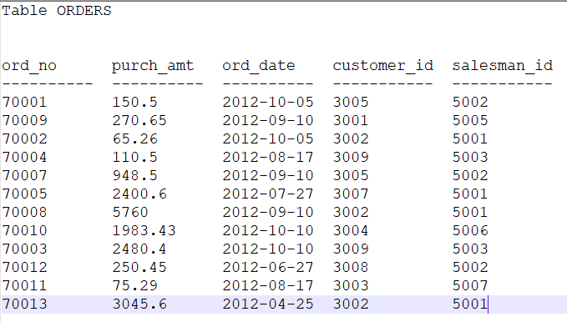

| 1. **TWO NUMBER SUM:**  * Write a function that takes in a non-empty array of distinct integers and an integer representing a target sum. If any two numbers in the input array sum up to the target sum, the function should return them in an array, in any order. If no to numbers sum up to the target sum, the function should return an empty array. * Note that the target sum has to be obtained by summing two different integers in the array. You cannot add a single integer to itself in order to obtain the target sum. * You can assume that there will be at most one pair of numbers summing up to the target sum.   **Sample Input:** numbers = [3, 5, -4 ,8, 11, 1, -1, 6] target_sum = 10  **Sample Output:** [-1, 11] the numbers can be in any order, it does not matter. | **22 points** |
| --- | --- |